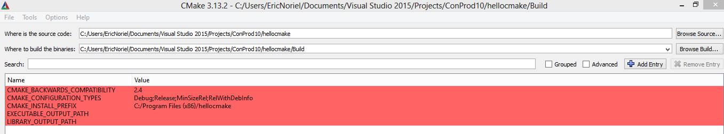

Testing c++ compiler

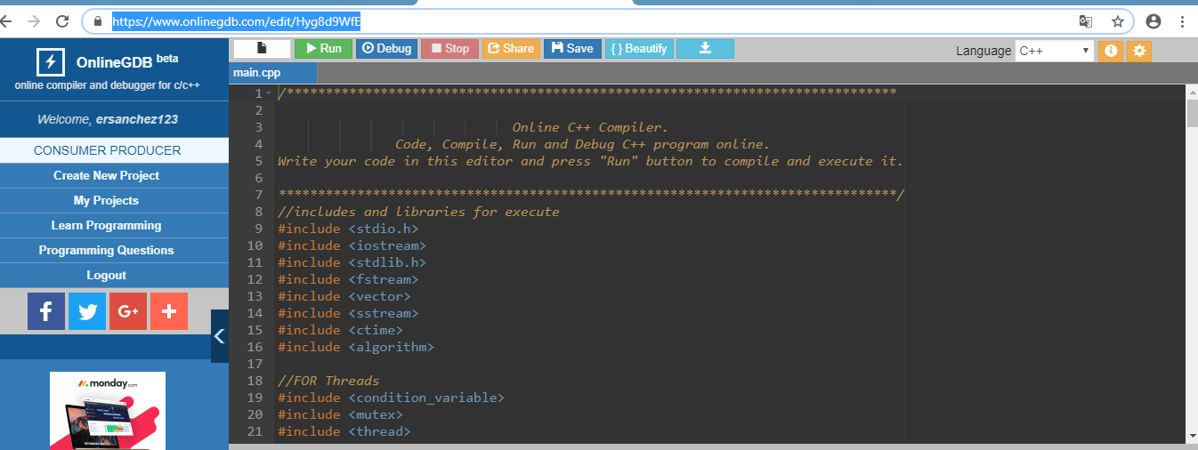

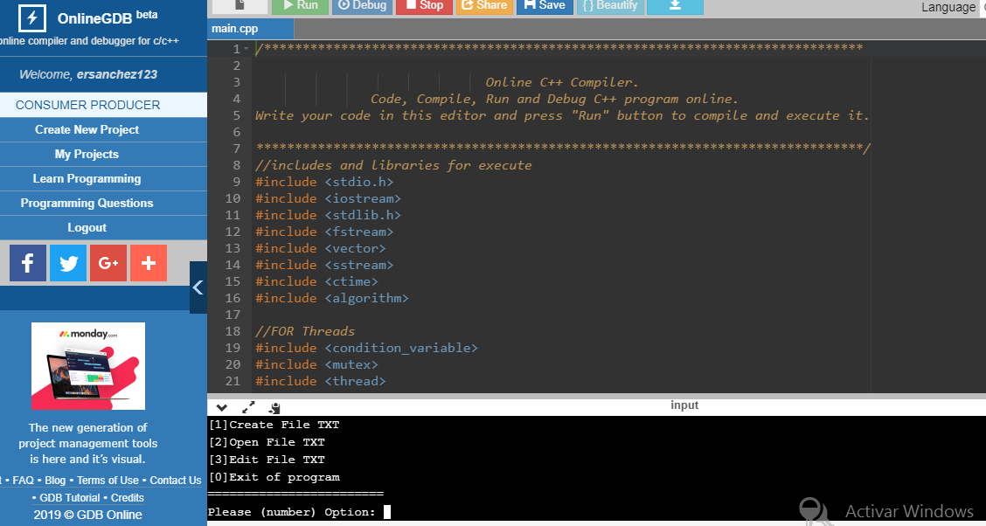

Option 1: Create File into Server with input values.

Option 2 : Read File in server and copy values into vector

Option 3 : Print Values and modified file.

Program contain 2 trhead:

1: order vector minimum maximus

2. Execute and print Vectors.

Regards

Eric Sanchez